# ABC Inventory Management

# Test Scenario: Search Product Scenario

# Scenario Description

This scenario is intended to test the Search functionality of the system. In this scenario a staff from a particular location logs in using their username and password. After this the staff uses the search functionality of the system. This is an important functionality as this system allows a staff to check the contents of each product size in different location.

# Version Control

|  |  |  |  |
| --- | --- | --- | --- |
| Version Number | Date | Author | Description |
| 5.0 | 13/09/2018 | Shirish Maharjan | Initial Draft |
| 5.1 | 14/09/2018 | Shirish Maharjan | First Version (Iteration 5) |

# Test Scripts

The following are the test scripts that will cover this scenario:

* SRP001 Search Product Script
* SRP002 Search Quantity Script

# Use Case

The use case covered by this test scenario is as follows:

* Search Product

# Test Components/ Requirements

This test scenario covers the following high-level testing requirements:

* Test the Search functionality of the system.
* Test if user can check product size content in different location.

Specific requirements will be covered in each test scripts provided below

# User Groups

* Staff (User)

# Test Scripts

The following are the elaboration of the test scripts mentioned above:

# SRP001: Search Product Script

## Script Description

This script follows each step while searching for a product in the database. This script will check if each step while searching the product is a success. If any step fails to succeed, a bug will be reported, and the test will be conducted again.

## Testing Requirements

This test will cover the Search Product functionality of the system.

## Setup

* The computer in the location is powered on.
* Make sure the computer is connected to the internet.
* Application is launched.
* Username and password are known.

## Teardown

* Conduct the SRP002 Script.

## Script Steps

|  |  |  |  |
| --- | --- | --- | --- |
| Step | Test Action | Expected Results | Pass/Fail |
| 1. | Application is launched. | System displays the ‘Login’ Page with the Username and Password field empty. | Pass |
| 2. | Enter username and password in the username and password field. | System waits till user to click on ‘Login’ button. | Pass |
| 3. | Click on the ‘Login’ button. | System grants access to the user and opens the Homepage | Pass |
| 4. | Click on the ‘Search Product’ button. | System launches the ‘Search Product’ page. | Pass |
| 5. | Enter the product code of the product. | System waits for the user’s action. | Pass |
| 6. | Click on the ‘Search’ button. | System displays the product details of the product code that was entered. | Pass |

### Result Screenshots

**Step 1**

Application launched, and login page is displayed.

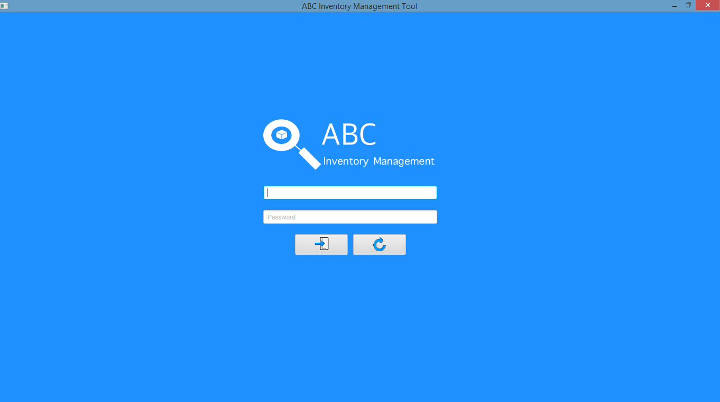

**Step 2**

Username and password are entered, and the system waits user to click on the ‘Login’ button.

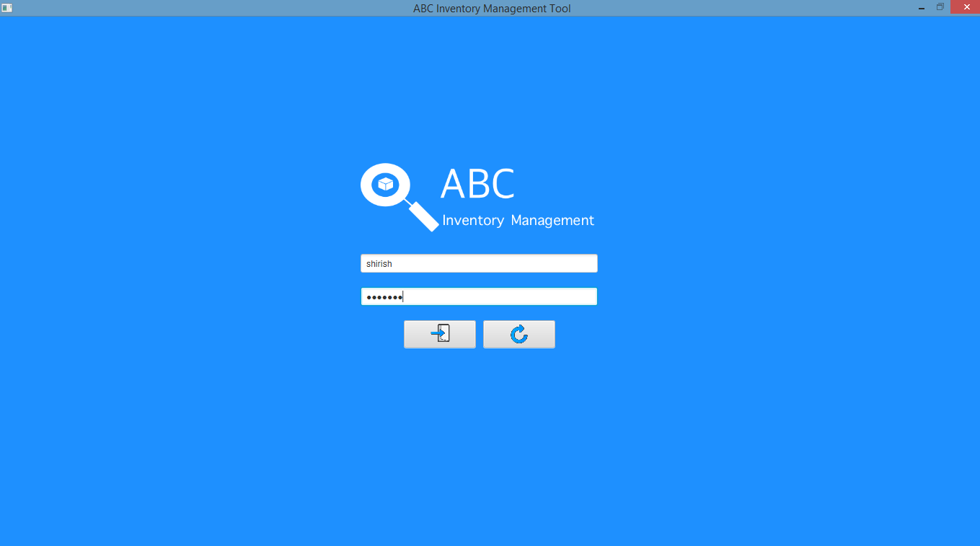

**Step 3**

After the ‘Login’ button is pressed at step 3, access is granted, and the Homepage is displayed.

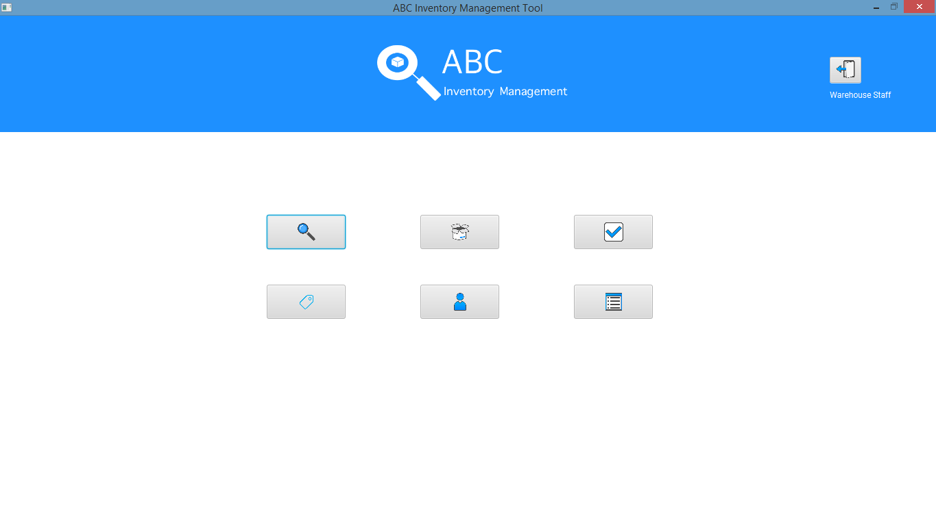

**Step 4**

After clicking on the ‘Search Product’ button, the system displays the ‘Search Product’ page.

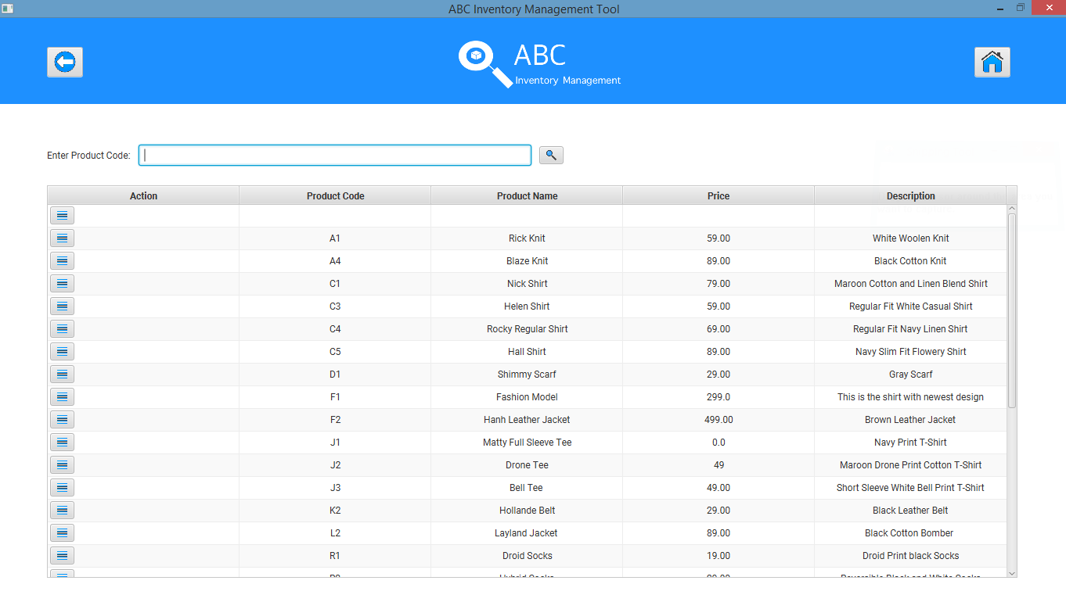

**Step 5**

User enters the ‘Product Code’ of the product that needs to be searched.

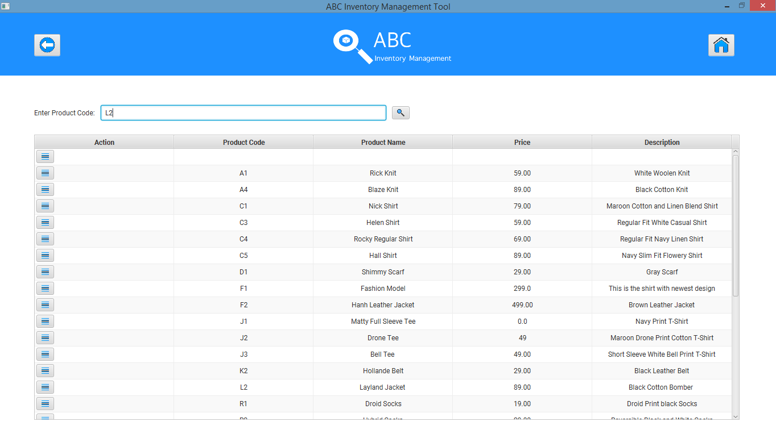

**Step 6**

After the user clicks on the ‘Search’ button, the system displays the details of the product if it exists.

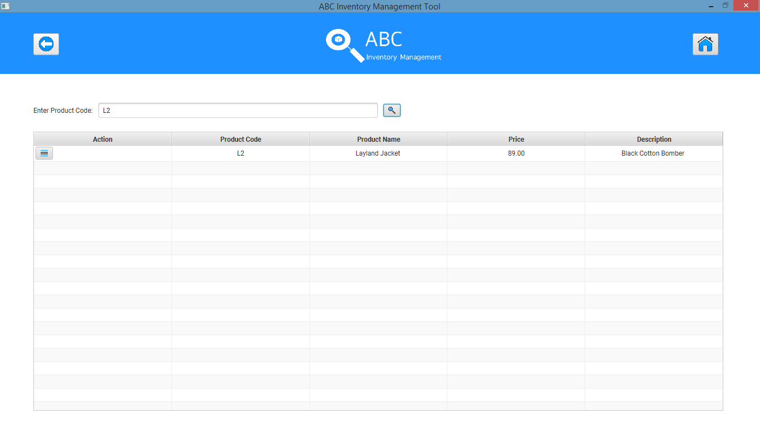

# SRP002: Search Quantity Script

## Script Description

This script follows each step while searching for the quantity of a particular size of the product in all stores after script SRP001. This script will check if each step while searching for the quantity in each store is a success. If any step fails to succeed, a bug will be reported, and the test will be conducted again.

## Testing Requirements

* This test will cover if the user can check product size content in different location.

## Setup

* SRP001 is completed.

## Teardown

* User can use any other functionality of the system.

## Script Steps

|  |  |  |  |
| --- | --- | --- | --- |
| Step | Test Action | Expected Results | Pass/Fail |
| 1. | User clicks on the ‘Detail’ button in the action column of the Product searched from SRP001. | System displays the various Product item (Sizes) that exist for the product. | Pass |
| 2. | User clicks on the ‘Detail’ button in the action column for the size they wish to view the quantity in each location for. | System displays the quantity of the size in each location where the product size exists along with the details of the location. | Pass |

### Result Screenshots

**Step 1**

After user conducts SRP001 and clicks on the ‘Details’ button of the product in the action column, the product items (sizes) that exist for the product along with other details is displayed.

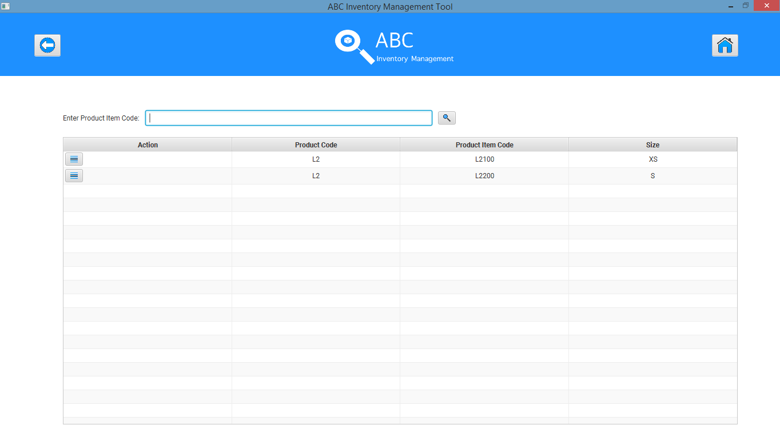

**Step 2**

After user clicks on the ‘Detail’ button in the action column for the size they wish to view the quantity in each location for, the quantity of size in each location where the product size exists along with the details of the location is displayed.

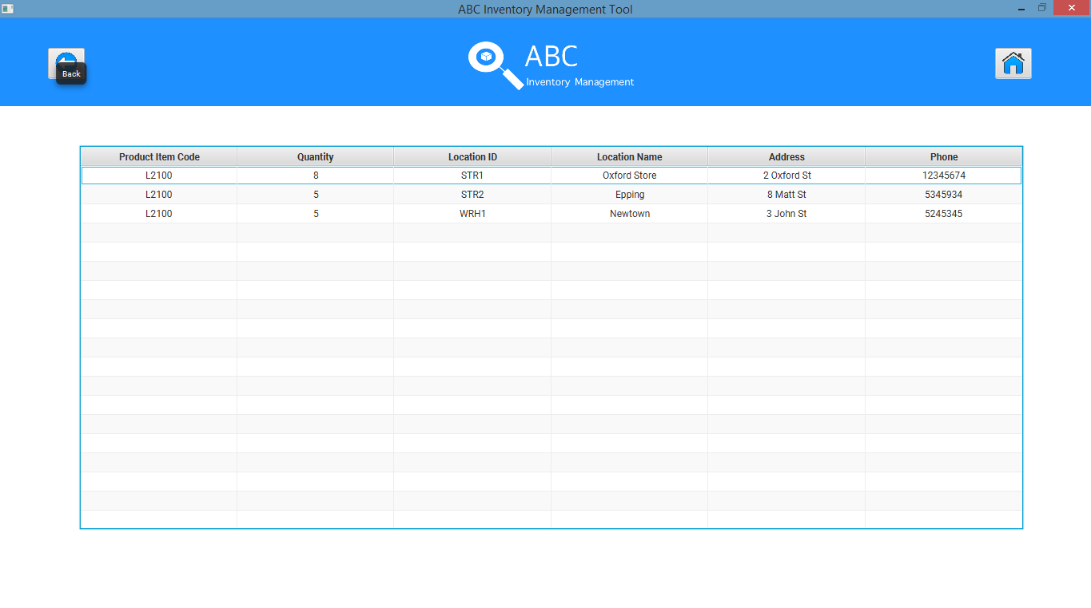

## Test Execution

|  |  |  |  |  |
| --- | --- | --- | --- | --- |
| Date/Time | Tester | Test ID | Test Phase | Status |
| 14/09/2018 | Shirish Maharjan | SM001 | Cycle 1 | Pass |